**3.2**

**Permissions needed for users and content**

Permissions are given to individuals at different levels, to allow;

* Guests
  1. Person who has access to a web site, can fill in forms for placing orders etc, but not allowed to create/change any part of the data/information.
* Users
  1. Ordinary account holders cannot access change/adapt data/information.
* Trusted Users

1. Usually, a person in an organisation who holds a managerial position, would need to access files to commit changes.

* Administrators

1. Do have full access to files/data/information, to enable them to organise who has the correct rights [Permissions] to use software applications. To ensure the software users cannot not overwrite important data, which the application relies on to run correctly.

* Developers

1. Require total access to administer updates and maintenance to the software.

|  |  |
| --- | --- |
| 1 | *Read Only* |
| 2 | *Read/Write* |
| 3 | *Read/Write/Execute* |
| 4 | *Full Access* |

**GitHub**

In GitHub the user will edit repositories, these will hold the files that will form your GitHub file account, these repositories can be given access permissions by the user/author, to enable or exclude other guests opening their work.

**Public Repositories**

Are visible to any user who has your GitHub e-mail address.

**Private Repositories**

Only available to the repository owner, usually the **author.**

The **author** can allow ‘***guests*’** different access rights to their work [Permissions], these can vary from allowing individuals the right to ‘Read Only’. ‘Read/Write’, ‘Read/write/execute’, the latter allows the guest to change the file content, this is when the **author** trusts the guest and is willing to share their work in a collaborative group.[1]

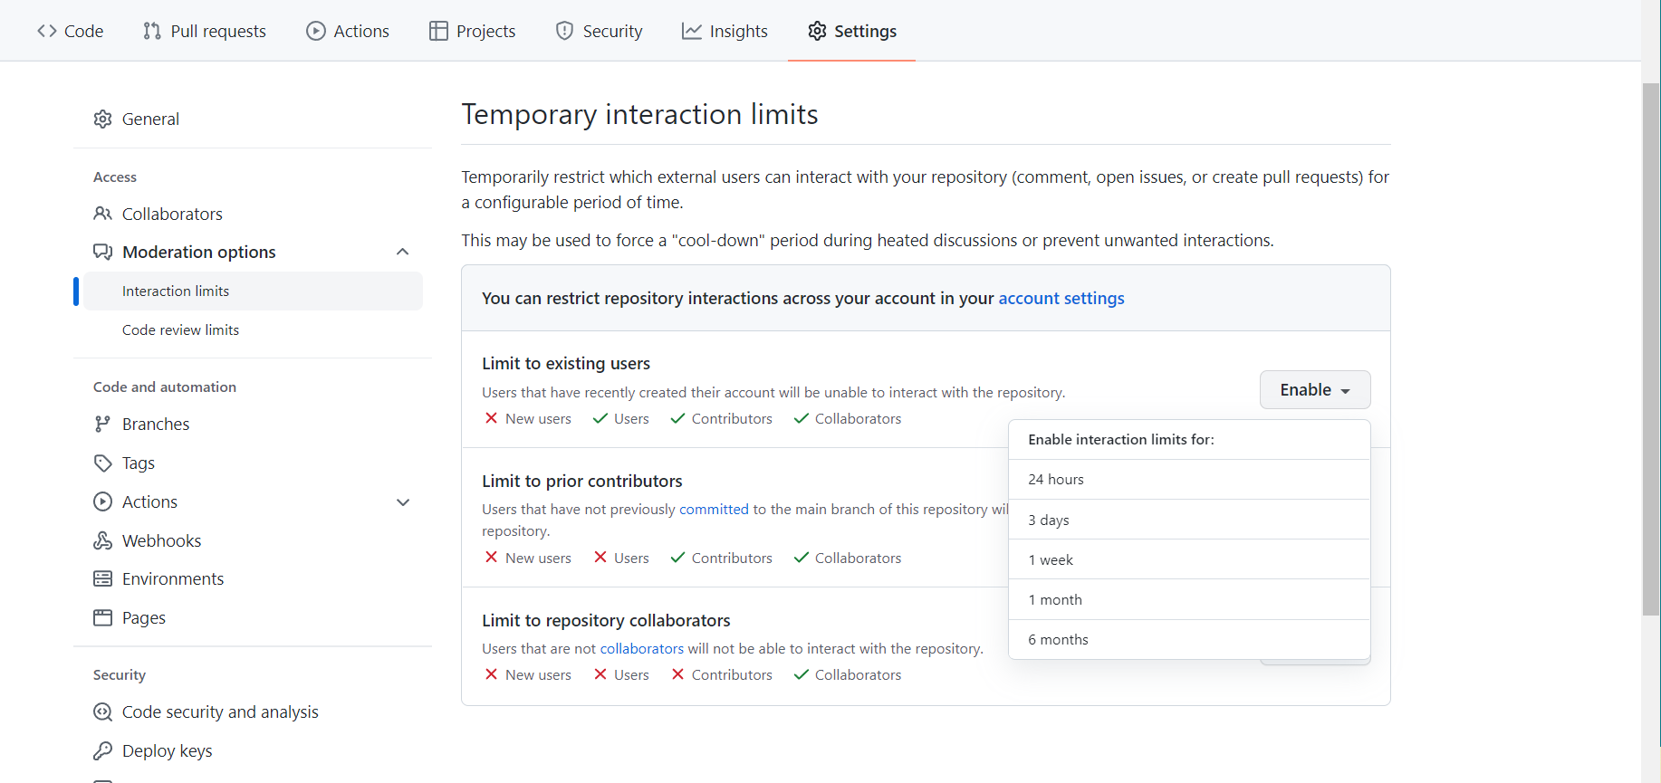

**Microsoft Word**

In Microsoft word, users can access the permissions by right clicking the file, and click properties;

By clicking the security tab, they will open the permissions;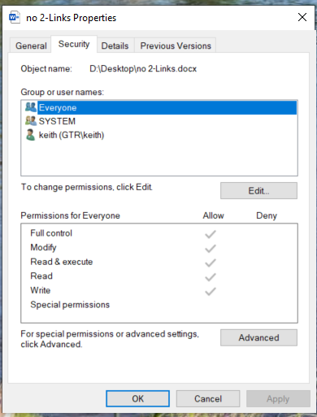

This dialogue box shows a group or users who have permissions, and what level of permissions the users have when accessing the file. To change the rights/permissions, the **author** can edit the permission levels, they wish for individuals or groups.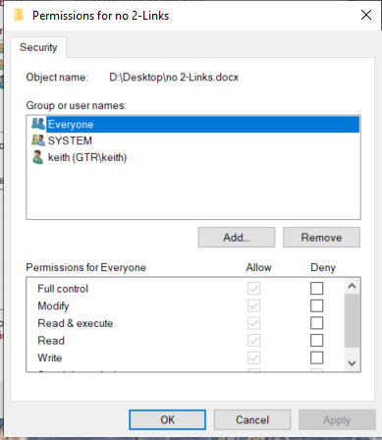

In the ‘**permissions for everyone**’ box, there are **allow & deny** buttons, which allow the **author** to adapt the levels for the individuals.

1. (kj, 2022)